**Types & Characters of OSPF Stubby Areas**

BINGNAN XU

ccnp (cisco certified network professional)

Sept. 2018

NEWPORT HIGH SCHOOL, WA

## Big Questions:

* Difference between stubby, totally stubby, nssa, totally nssa vs. normal network
* How to distinguish each OSPF modes in an established network
* Difference between LSA types and how they relate between the different networks.

This is a research-based lab. There is no actual on rack configuration in this section.

## LSA (Link state advertisment) types

Link State Advertisement (LSA) is the message that routers send to each other so that they can establish dedicated routes to each other. Imagine each router is a student in a classroom: each router is speaking (broadcasting) their IPs and routing tables to every other router in its OSPF area.

### LSA type 1: (router lsa)

Type 1 LSA establishes a list of all directly connected links to this router; it tells the router rather its neighbors are “alive”. If R1 no longer receives LSA type 1 from one of its ports, it knows that his neighbor in that port has been removed, and R1 will modify its OSPF routing table. When a new OSPF running router (R1) enters the area, it sends Type 1 LSA to detect directly connected routers in its area and acknowledge that it runs OSPF.

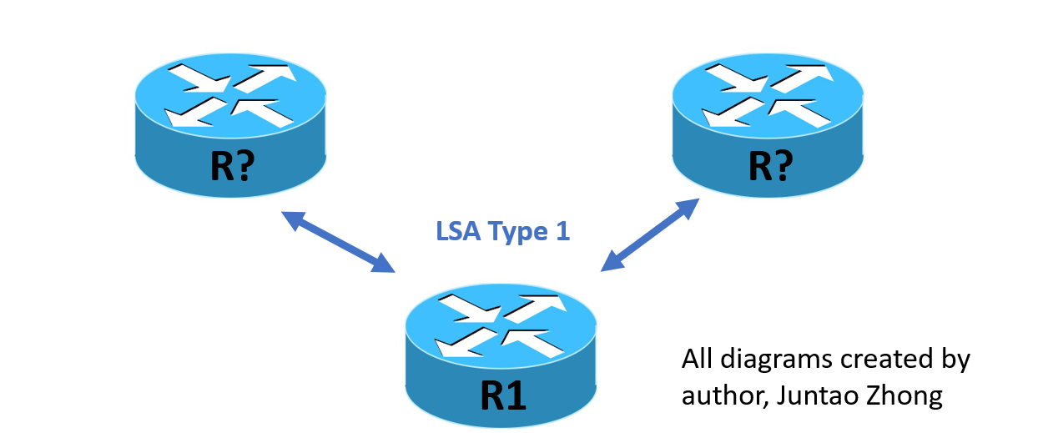

### LSA type 2: (network LSA)

Designated Router (DR, in this case R3) tell every router in its area that it is the lead router in Area 1. After an automated DR election (or technician can configure a preempt router), DR router tells other routers in its area that it is the DR (lead) of that area. DR acknowledge its leadership role with LSA type 2. Keep in mind that LSA type 2 is limited in one area—Type 2 LSAs from area 1 DR only stay in area 1, never go beyond area 1.

LSA Type 1 and Type 2 are the basic of OSPF operation and they enable routers in one area to communicated with each other.

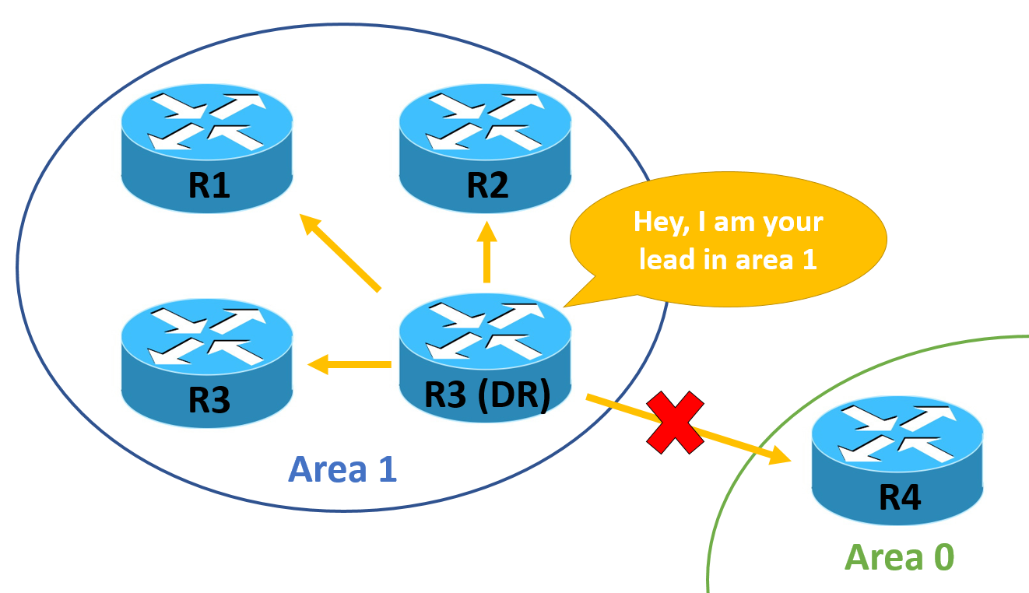

### LSA type 3: (summary LSA)

LSA Type 3 help routers exchange OSPF routing table between areas. R2 (Area border router that connects two areas) stores OSPF routing table from Area 1 and floods it into Area 0 (backbone area) with type 3LSA information. Area 0 forward it to other areas in OSPF network. In another word, routers in backbone area received Type 3 LSAs from an area (say, area 1); they add the routes to their OSPF routing table and forward the routes to other areas in OSPF network.

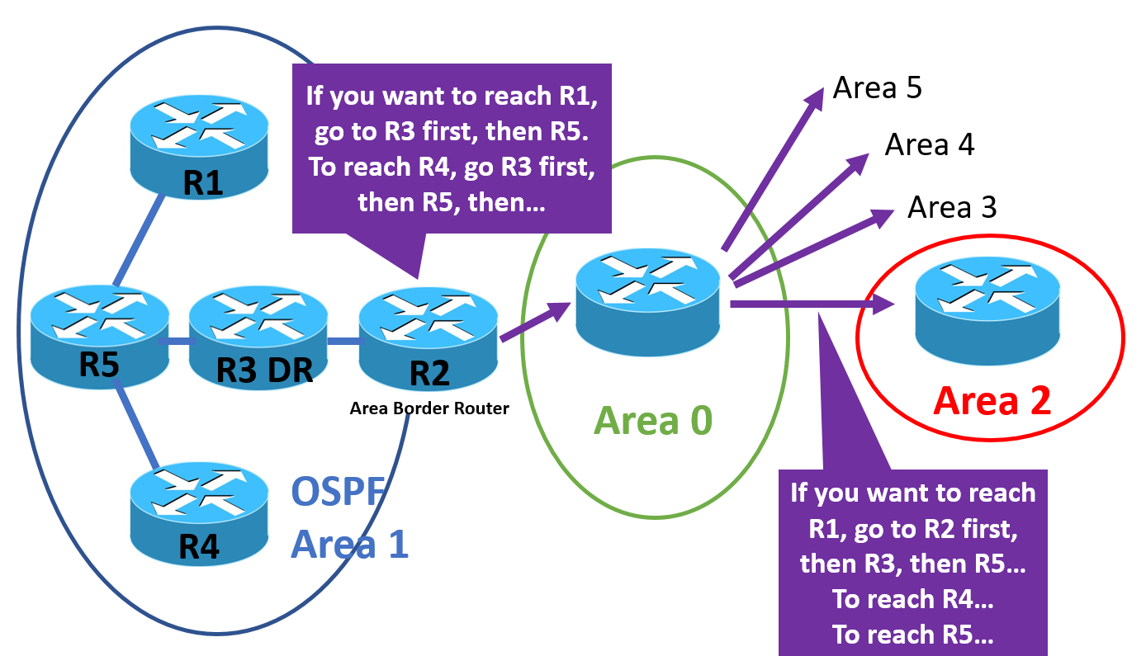

### LSA type 4: (summary asbr lsa)

So, what about networks that don’t use OSPF? For example, an external network that uses RIP? ASBR (Autonomous System Border Router, in this case R5) connects to an OSPF area and an external network (in this case, RIP network). After R5 detects the external network, it flips a bit in its LSAs and informs its DR (R3) that it is connected to a non-OSPF area. Then, DR creates Type 4 LSAs and flood other areas, so that all routers in the OSPF network can locate R5 in area 1. Though summary ASBR LSA, other routers also learn that R5 is an ASBR and that R5 is connected to an external network. 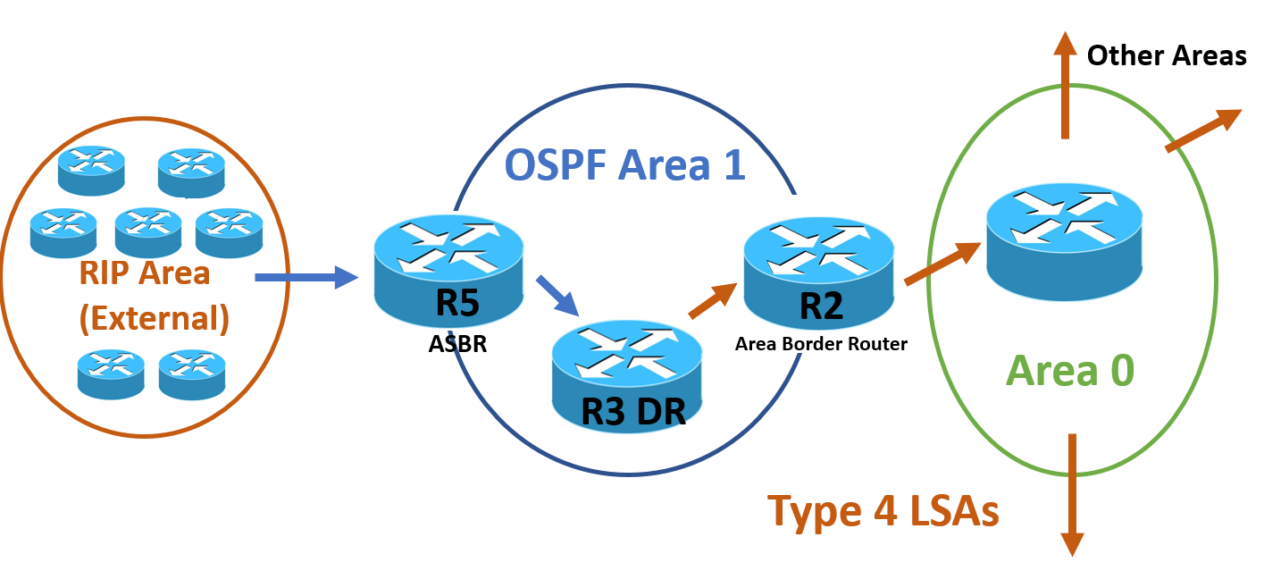

### LSA type 5: (Autonomous system external LSA)

Now, other routers know ASBR (R5) is connected to an external network, but how can they get to the external network? ASBR (R5) will create a Type 4 LSA, so other routers can also learn the external RIP network and put those routes into their routing table.

LSA Type 4 and Type 5 are very much linked together, because routers in other areas cannot establish connection to external networks unless they locate ASBR (R5) through LSA type 4. Type 5 LSAs are filtered in stubby areas.

### LSA type 6 and type 8 will not be discussed here

### LSA type 7: (NOT-SO-STUBBY AREA lsa)

Type 7 LSA is solely designed for nssa. Stubby areas cause problems by prohibiting Type 4, 5 LSAs and ASBR routers, because the areas are not allowed to process or transverse external routes. With Type 7 LSA, ASBR can exist in a stubby area and Type 5 LSA can traverse in form of Type 7 LSA.

In another word, not-so-stubby area LSAs guiles type 5 LSAs across Area 1 to backbone area without being filtered; it’s not processed by routers in nssa area (other routers don’t need to maintain OSPF routing table for RIP area)

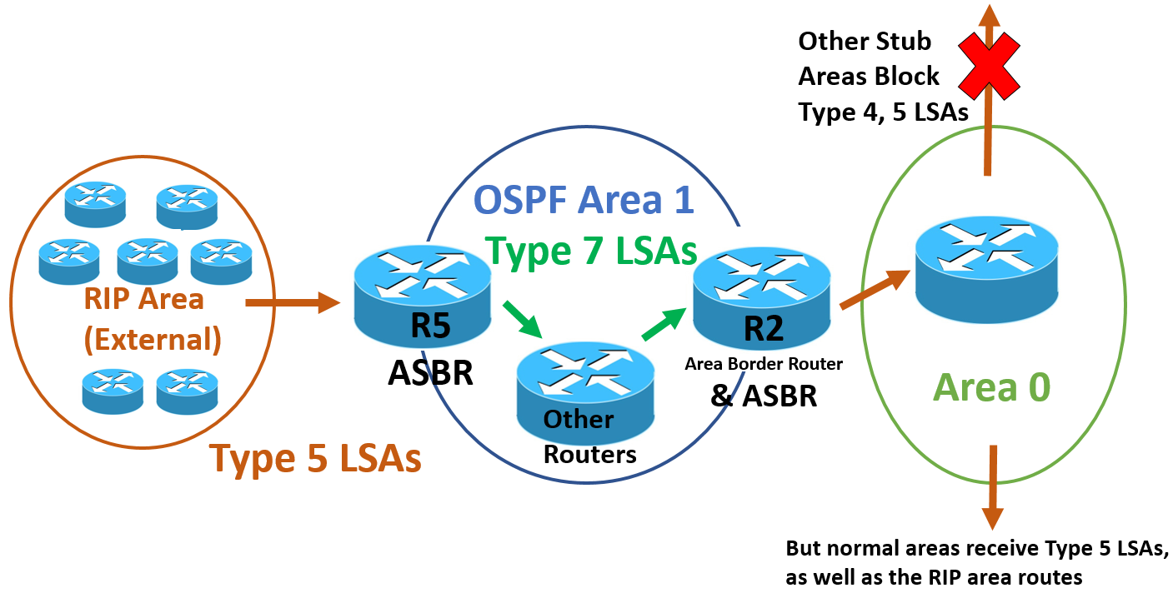

## OSPF stubby options summary

LSA data can have substantial size in a large OSPF network, thus taking a lot of router resources and slowing down the network. Stubby OSPF reduces routers’ memory consumption and CPU workload by using default routes inside an area (so instead of letting everyone look for everyone else in a giant room, ABRs direct routers to find other routers). In this way, only 1 router in the area (ABR) needs to maintain the OSPF routing table. In another word, ABRs in stubby area advertise a default route into their area, so other routers in the area are freed from OSPF calculation.

| Normal | Any LSA types are allowed |
| --- | --- |
| Stubby | No Type 4, 5 LSA allowed |
| Totally Stubby | No Type 3, 4, or 5 LSA allowed, though default summary routes are allowed |
| NSSA (No So Stubby Area) | No Type 4, 5 LSA allowed, but Type 7 LSAs are allowed (Type 5 converted by NSSA ASBR) |
| Totally NSSA | No Type 3, 4, or 5 LSA Allowed: default summary routes and Type 7 LSAs. |

## types of packets expected in different ospf modes

If I were to distinguish different OSPF mode in an established network, I would capture the traffic packets in the network. In normal OSPF network, I will see every LSA types except type 7. In a stubby network, I will likely to find Type 1, 2, 3 LSAs, because LSAs for external networks are blocked (Type 4 and 5 are filtered). In a totally stubby area, I can only fine Type 1 and 2, because Type 3 (interarea LSA) is blocked. In a nssa network, 1, 2, 3, and 7 LSA packets would be captured, because nssa turn LSA type 5 into type 7. In a Totally NSSA, interarea Summary LSA is filtered and I will find LSA Type 1, 2, 7.

| Normal OSPF | LSA type 1, 2, 3, 4, 5 |
| --- | --- |
| Stubby | LSA type 1, 2, 3 |
| Totally Stubby | LSA type 1, 2 |
| NSSA (no so stubby area) | LSA type 1, 2, 3, 7 |
| Totally NSSA | LSA type 1, 2, 7 |

## Opsf stubby options explained

### OSPF stubby area

Routers in stubby area filter out type 4 and 5 LSA, which means routers in stubby area will not maintain routing table for non-OSPF area. Stubby routers can, however, establish connection with non-OSPF network (RIP area for example) via summary routes from designated router (DR). Simply put, a centralized DR maintains routing tables of external network; then, it distributes summary routes to in the entire OSPF area. In this way, when other routers want to reach the external network, they just need to follow the DR “guide” instead of remembering the routes themselves.

### OSPF totally stubby

Like stubby, routers in totally stubby area connect non-OSPF networks through DR’s summary routes. But totally stubby goes one step further: routers in totally stubby don’t maintain routing table to other OSPF areas. Thus, routers in OSPF area 1 connect with routers in other areas through DR’s summary routes. The difference between Stubby and Totally Stubby is that routers (except DR) in a totally stubby area rely on DR to reach other OSPF areas and external networks (Stubby areas need DR to reach only external networks). In this way, routing table is more centralized in DR and less resources are used in other routers in Totally Stubby area.

### NSSA (no so stubby area)

Since traditional stubby area filters LSA information from other routing protocols (non-OSPF), problems are generated when an area want to bypass a stubby area to learn about external routes. For example, routers in area 0 can’t learn about RIP routes connected to routers in RIP network. Thus, other OSPF areas cannot learn about RIP network just because area 1 is stub network.

Is there a way to make area 1 a stub network (no RIP network in routing table), but still let other areas know the RIP network? By configuring area 1 as nssa, we can have area 1 turn Type 5 LSA into Type 7, and send Type 7 LSAs to area 0. Routers in area 1 only transfer, but do not process, external LSAs into area 0, so that area 0 can learn external routes (You can refer back to LSA Type 7 for more information).

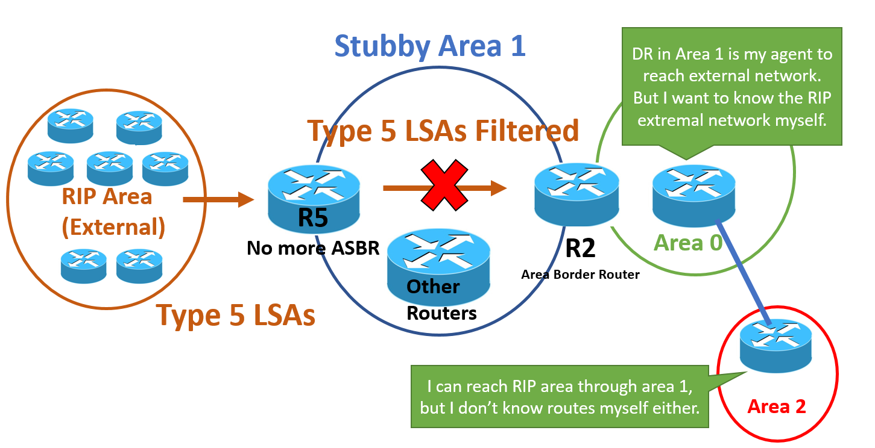

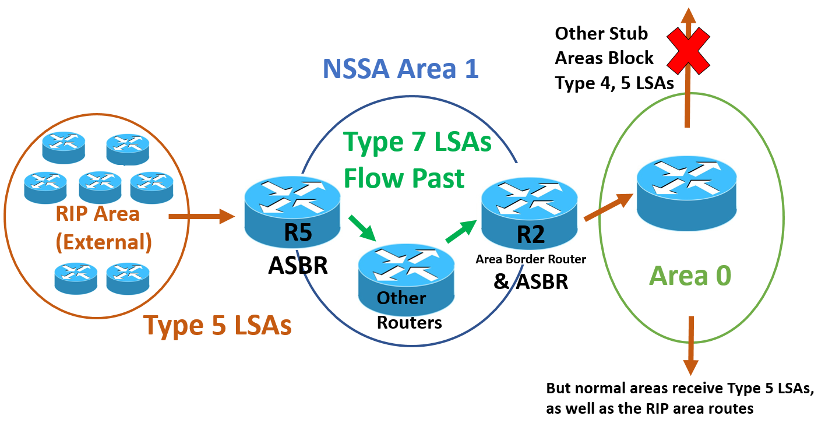

### totally NSSA

Term “totally” refers to the blocking of type 3 LSA (inter-area LSA). Routers in totally nssa area transfer LSA type 5 in form of LSA type 7, but don’t learn routes from other OSPF areas.